**Tomely Screen Navigation**

1. **Register User – New Account**
   1. Click on Student/Teacher Button on Home Page
   2. Click on “NEW HERE? SIGN UP” button
   3. User will be navigated to the Register User page where the user can enter the profile details and register themselves as Student or Teacher.

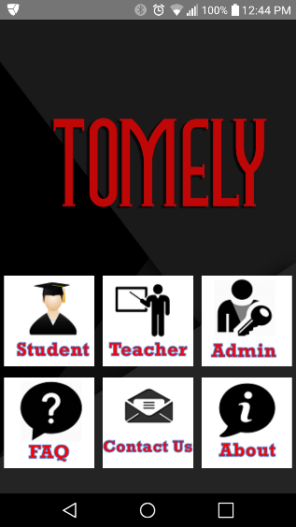 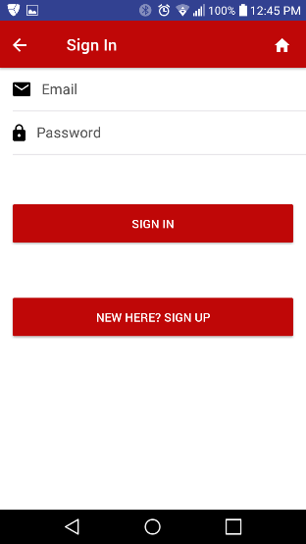 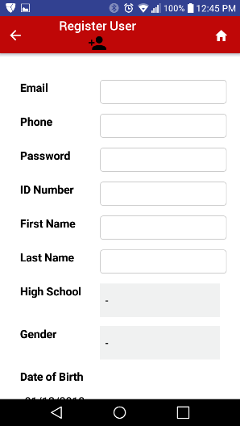

1. **Login to Tomely – Existing User**
   1. Click on Student/Teacher Button on Home Page
   2. Enter email/password at Sign In page
   3. Upon successful login, Teacher will be navigated to Teacher Home Screen, Student user will be navigated to Student Home page and Admin user will be navigated to the Admin Home page.

  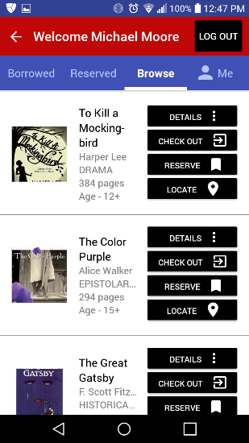

In case of login failure, a detailed error message will be displayed on the Sign In page.

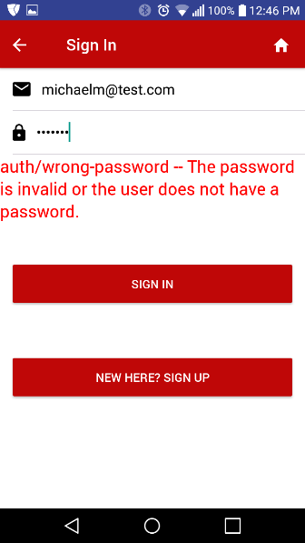

1. **About Page**
   1. Click on About button on Home Page
   2. User will be navigated to the About page

 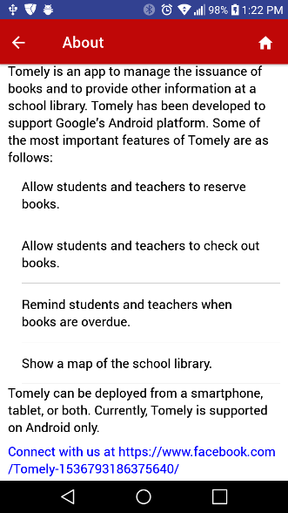

1. **FAQ Page**
   1. Click on FAQ button on Home page
   2. User will be navigated to the FAQ page

 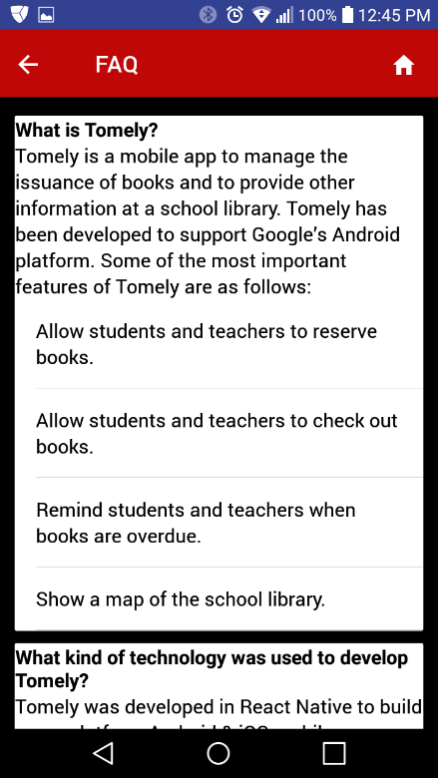

## **Contact Tomely Admin**

* 1. Click on Contact Us button on Home page
  2. User will be navigated to the Contact Us page where the user can provide the Name, Email and a brief message and click on “Send”. A notification message will be sent to the Admin team.

 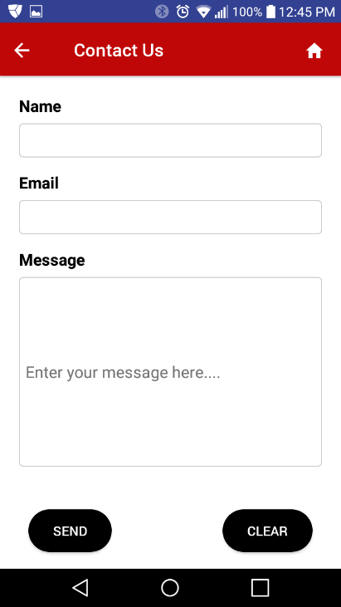

# **Student/Teacher Functions**

## **Browse Books**

* 1. Click on Student/Teacher Button on Home Page
  2. Enter email/password at Sign In page
  3. On Student Home Page, click on “Browse” Tab

  

## **Check-Out Books**

* 1. Click on Student/Teacher Button on Home Page
  2. Enter email/password at Sign In page
  3. On Student Home Page, click on “Browse” Tab
  4. Click on “CHECK OUT” button
  5. On successful, check-out a popup is displayed

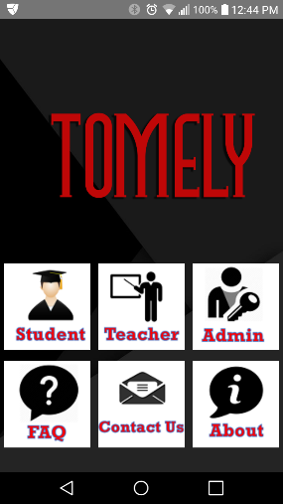 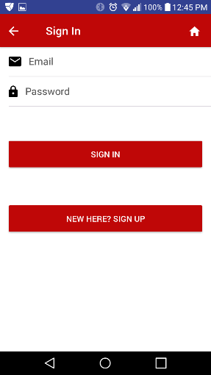 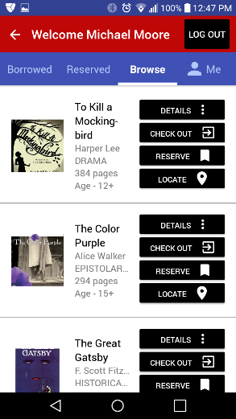 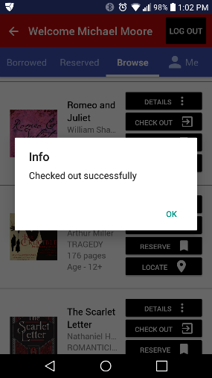

## **Reserve Books**

* 1. Click on Student/Teacher Button on Home Page
  2. Enter email/password at Sign In page
  3. On Student Home Page, click on “Browse” Tab
  4. Click on “RESERVE” button
  5. A popup dialog is displayed on successful reservation

   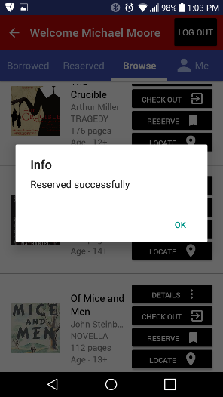

## **View Book Details**

* 1. Click on Student/Teacher Button on Home Page
  2. Enter email/password at Sign In page
  3. On Student Home Page, click on “Browse” Tab
  4. Click on “DETAILS” button
  5. A popup dialog with the book details is displayed

   

## **Locate Book**

* 1. Click on Student/Teacher Button on Home Page
  2. Enter email/password at Sign In page
  3. On Student Home Page, click on “Browse” Tab
  4. Click on “Locate” button
  5. A popup dialog with the books location is marked within the library map.

   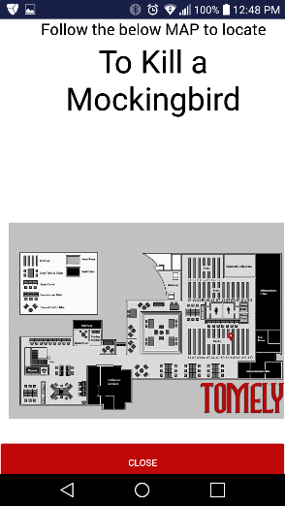

## **View User Profile**

* 1. Click on Student/Teacher Button on Home Page
  2. Enter email/password at Sign In page
  3. On Student Home Page, click on “Me” Tab
  4. User will be navigated to the User Profile page.

   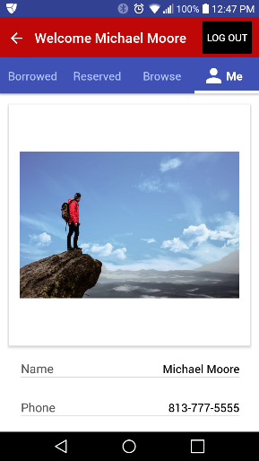

# **Admin Functions**

1. **Admin Home Page (Search Users is start page)**
   1. Click on Admin Button on Home Page
   2. Enter email/password at Sign In page
   3. User will be navigated to the Admin Home Page with the “Search Users” tab selected as the default screen

  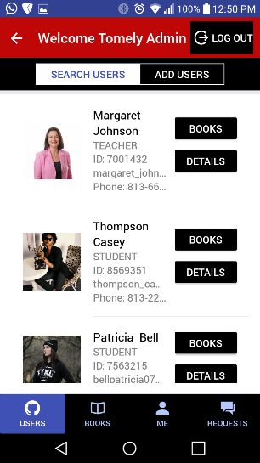

1. **Admin – Add Users**
   1. Click on Admin Button on Home Page
   2. Enter email/password at Sign In page
   3. User will be navigated to the Admin Home Page
   4. Click on the “Add Users” tab
   5. Admin will be navigated to the Add User screen where the user can be added
   6. Admin can click on the “Details” button to see the User Profile details

  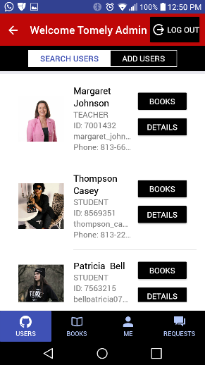 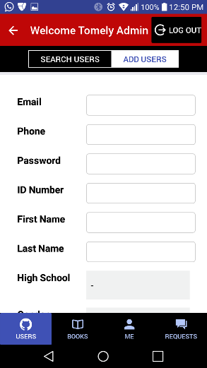

1. **Admin – Search Books**
   1. Click on Admin Button on Home Page
   2. Enter email/password at Sign In page
   3. User will be navigated to the Admin Home Page
   4. Click on the “Books” footer tab
   5. Admin will be navigated to the Books screen with “Search Books” tab selected by default
   6. Admin can click on the “Details” or “Locate” button to get more details on the book or the location of the book

  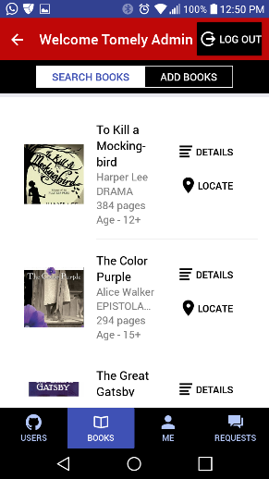

1. **Admin – Add Books**
   1. Click on Admin Button on Home Page
   2. Enter email/password at Sign In page
   3. User will be navigated to the Admin Home Page
   4. Click on the “Books” footer tab
   5. Admin will be navigated to the Books screen with “Search Books” tab selected by default
   6. Click on the “Add Books” tab to navigate to the Add Book page where admin can add books to the Tomely library database.

  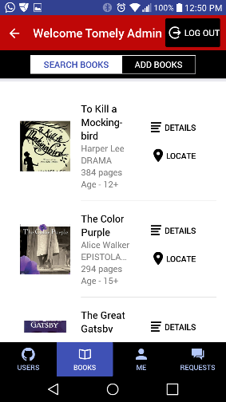 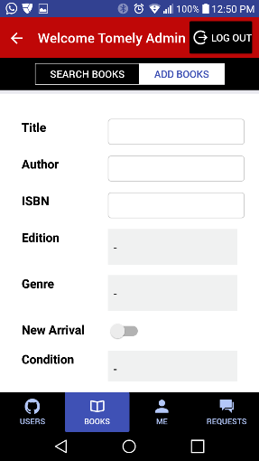

1. **Admin – Check In Books**
   1. Click on Admin Button on Home Page
   2. Enter email/password at Sign In page
   3. User will be navigated to the Admin Home Page
   4. User will be navigated to the Admin Home Page with the “Search Users” tab selected as the default screen
   5. Find the user who is trying to check-in the book
   6. Click on the “Books” button the specific user
   7. All books activity for the user will be displayed.
   8. Find the book the user wants to return and click on “CHECK IN” button. (**Note: Only the books checked-out by the users will have the “CHECK IN” button. The Reserved books will not have a “CHECK-IN” button

  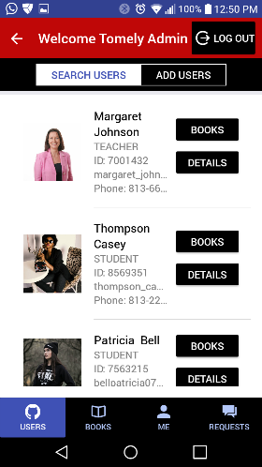 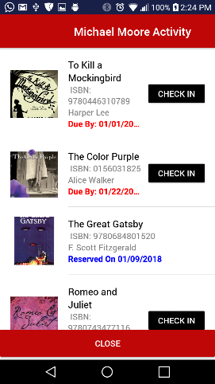

* 1. Upon successfully checking in the book, a popup dialog with the success message is displayed

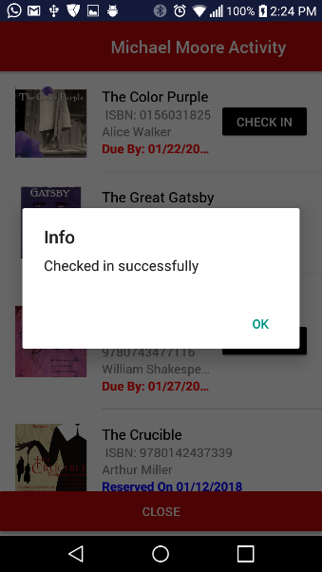

1. **Admin – Handling User Requests**
   1. Click on Admin Button on Home Page
   2. Enter email/password at Sign In page
   3. User will be navigated to the Admin Home Page
   4. User will be navigated to the Admin Home Page with the “Search Users” tab selected as the default screen
   5. Click on the “Requests” footer tab
   6. User will be navigated to the “Requests” page with “NEW” Requests as the default page.
   7. Once the request has been reviewed, Admin can click ok “Review” to mark the request as “Reviewed”. The request message will now appear in the “Reviewed” tab
   8. When the Admin completes the request like adding user, reset user password etc, the Admin can click on the “Complete” button to mark the request as completed.

***Note: Currently, Tomely does not send notifications back to the Users who submitted a request with the request status/updates. In the future release, we will enhance the application to notify the users of the request status and updates.

  